**FAMILY WEALTH GOAL ACHIEVER™ - INITIAL**

PREPARED FOR:

DUNCAN AND TINA LEWIS

April 27, 2011

DRAFT FOR DISCUSSION PURPOSES ONLY

PRESENTED BY

William Fahey Fahey Investment Planning, LLC 3135 N 17th Street Arlington, VA 22201 wfahey@fahey.co Phone: (703)528-8063

Copyright 2011 InKnowVision, LLC

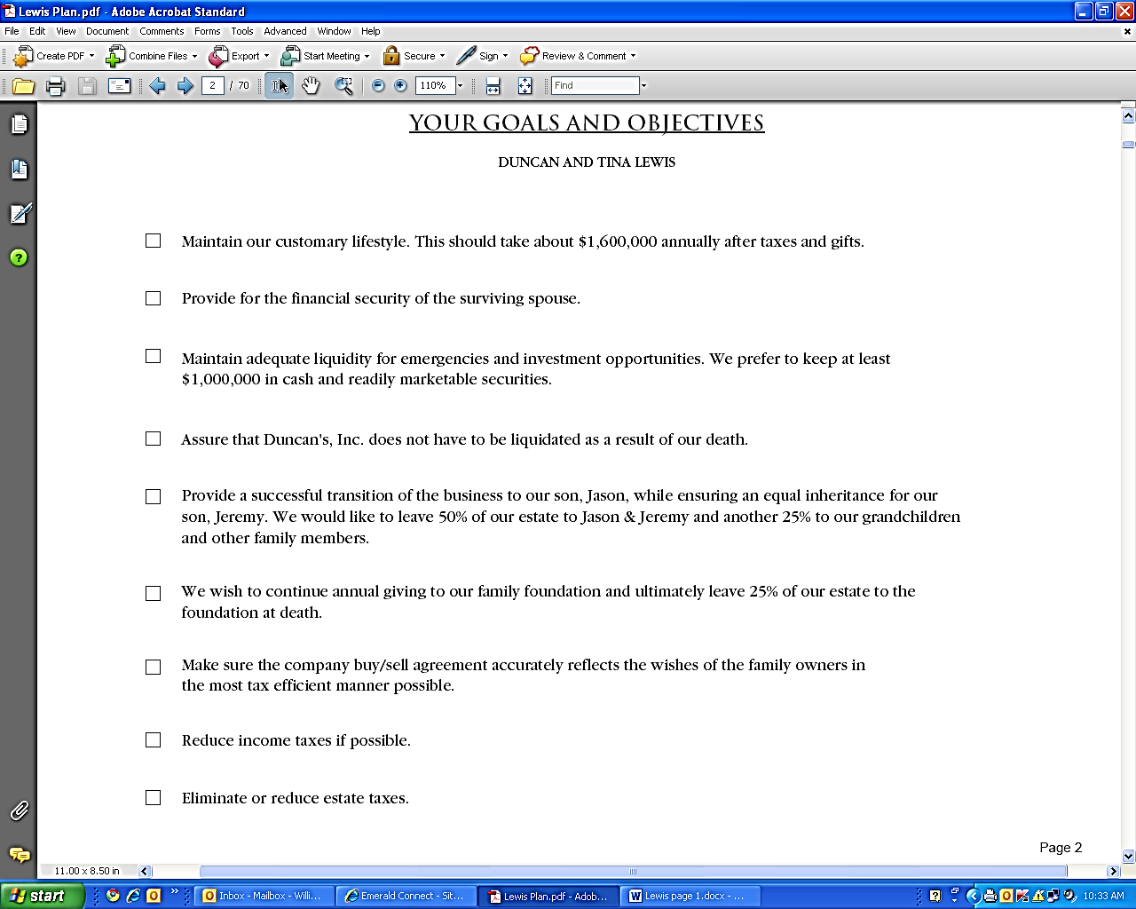

Page 2

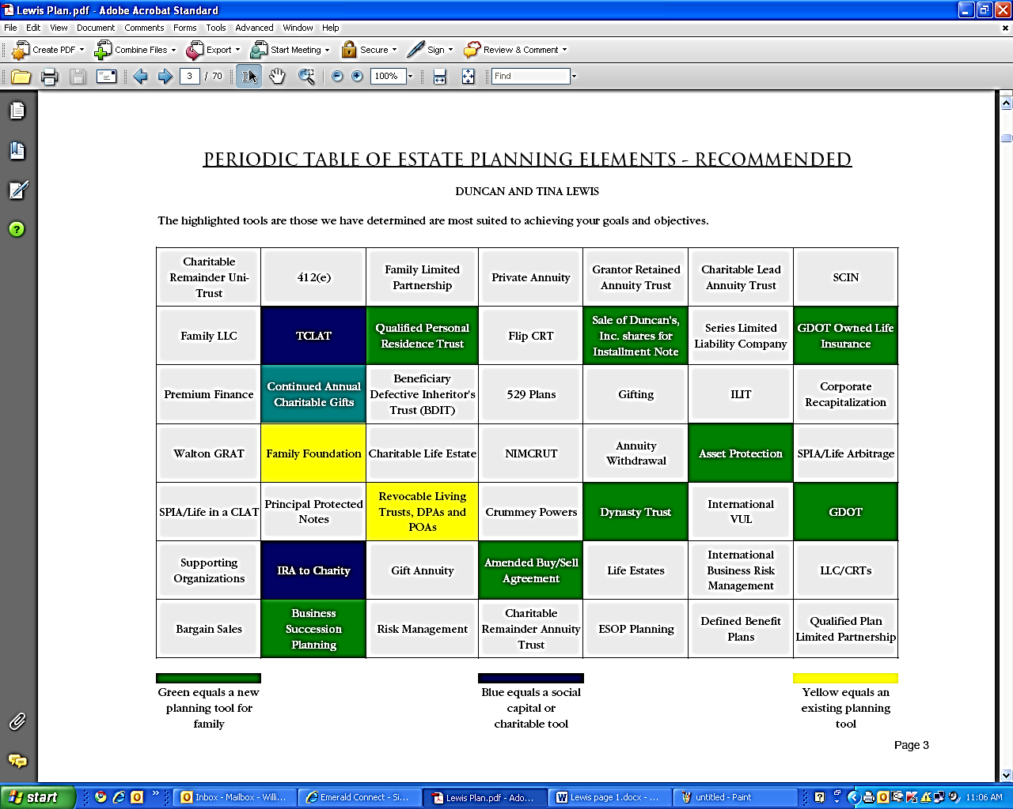

Page 3

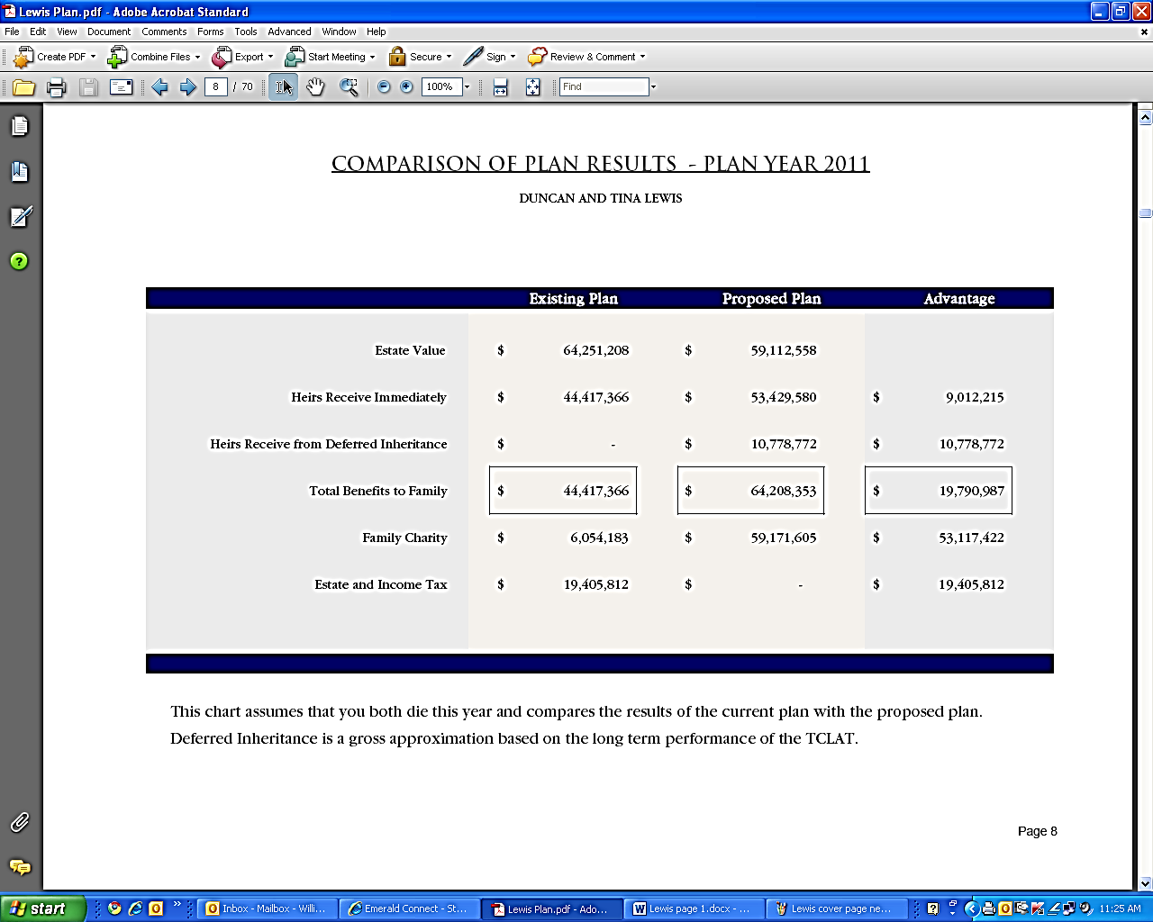

Page 8

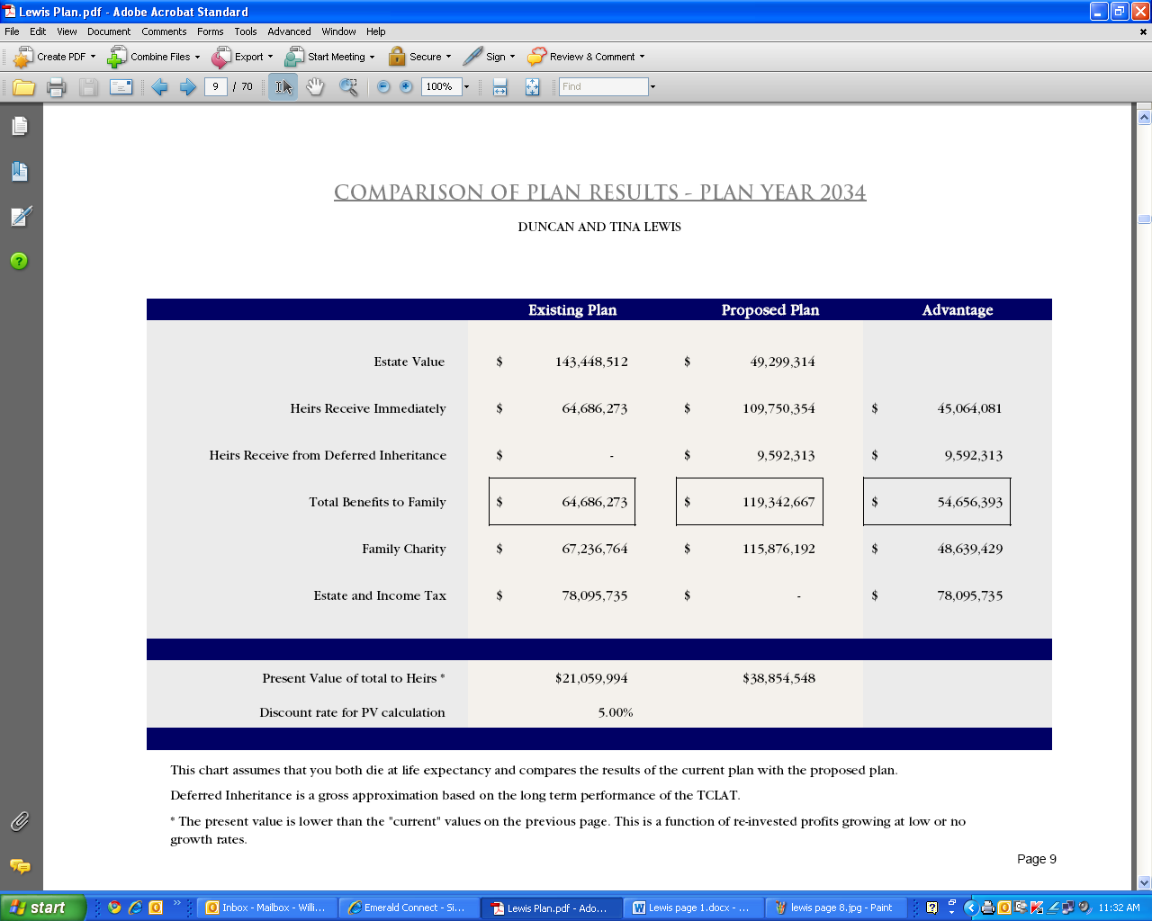

Page 9